***Arrays***

*The purpose of this assignment is to give you practice writing programs with arrays.*

1. **Discrete distribution.** Write a program DiscreteDistribution.java that takes an integer command-line argument *m*, followed by a sequence of positive integer command-line arguments a1,a2,…,an1, and prints *m* random indices (separated by whitespace), choosing each index i with probability proportional to ai.
2. ~/Desktop/arrays> java DiscreteDistribution 25 1 1 1 1 1 1
3. 5 2 4 4 5 5 4 3 4 3 1 5 2 4 2 6 1 3 6 2 3 2 4 1 4
4. ~/Desktop/arrays> java DiscreteDistribution 25 10 10 10 10 10 50
5. 3 6 6 1 6 6 2 4 6 6 3 6 6 6 6 4 5 6 2 2 6 6 2 6 2
6. ~/Desktop/arrays> java DiscreteDistribution 25 80 20
7. 1 2 1 2 1 1 2 1 1 1 1 1 1 1 1 2 2 2 1 1 1 1 1 1 1
8. ~/Desktop/arrays> java DiscreteDistribution 100 301 176 125 97 79 67 58 51 46
9. 6 2 4 3 2 3 3 1 7 1 1 3 4 7 1 4 2 2 1 1 3 1 8 6 2
10. 1 3 6 1 8 5 1 3 6 1 1 2 3 8 7 4 6 4 3 1 5 3 3 7 3
11. 1 3 1 7 7 2 2 3 6 5 4 1 1 1 7 2 3 5 2 2 1 4 1 2 1
12. 2 1 2 2 3 2 8 4 3 2 1 8 3 5 3 3 8 1 2 3 3 1 2 3 1

To generate a random index i with probability proportional to ai:

* + Define the cumulative sums Si=a1+a2+…+ai with S0=0.
  + Pick a random integer r uniformly between 0 and Sn−1.
  + Find the unique index i between 1 and n  such that Si−1≤r<Si.

Geometrically, this subdivides the interval [0,Sn) into *n* subintervals [Si−1,Si), with the length of subinterval *i* proportional to ai. For example, if the discrete distribution is defined by

(a1,a2,a3,a4,a5,a6)=(10,10,10,10,10,50),

then the cumulative sums are

(S1,S2,S3,S4,S5,S6)=(10,20,30,40,50,100)

and the following diagram illustrates the 6 subintervals:

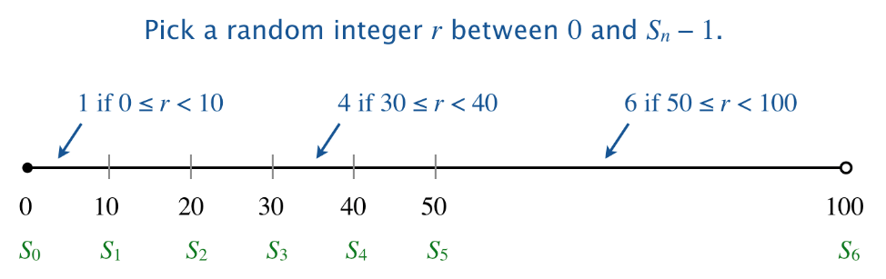

*In probability theory, this is known as sampling from a discrete distribution.*

2. **Thue–Morse weave.** Write a program ThueMorse.java that takes an integer command-line argument *n* and prints an *n*-by-*n* pattern like the ones below. Include two space characters between each + and - character.

1. ~/Desktop/arrays> java ThueMorse 4
2. + - - +
3. - + + -
4. - + + -
5. + - - +
6. ~/Desktop/arrays> java ThueMorse 8
7. + - - + - + + -
8. - + + - + - - +
9. - + + - + - - +
10. + - - + - + + -
11. - + + - + - - +
12. + - - + - + + -
13. + - - + - + + -
14. - + + - + - - +
15. ~/Desktop/arrays> java ThueMorse 16
16. + - - + - + + - - + + - + - - +
17. - + + - + - - + + - - + - + + -
18. - + + - + - - + + - - + - + + -
19. + - - + - + + - - + + - + - - +
20. - + + - + - - + + - - + - + + -
21. + - - + - + + - - + + - + - - +
22. + - - + - + + - - + + - + - - +
23. - + + - + - - + + - - + - + + -
24. - + + - + - - + + - - + - + + -
25. + - - + - + + - - + + - + - - +
26. + - - + - + + - - + + - + - - +
27. - + + - + - - + + - - + - + + -
28. + - - + - + + - - + + - + - - +
29. - + + - + - - + + - - + - + + -
30. - + + - + - - + + - - + - + + -
31. + - - + - + + - - + + - + - - +

The [*Thue–Morse sequence*](https://en.wikipedia.org/wiki/Thue%E2%80%93Morse_sequence) is an infinite sequence of 0s and 1s that is constructed by starting with 0 and successively appending the *bitwise negation* (interchange 0s and 1s) of the existing sequence. Here are the first few steps of this construction:

00101100110100101101001100101100010110011010010110100110010110

To visualize the Thue–Morse sequence, create an *n*-by-*n* pattern by printing a + (plus sign) in row i and column j if bits i and j in the sequence are equal, and a - (minus sign) if they are different.

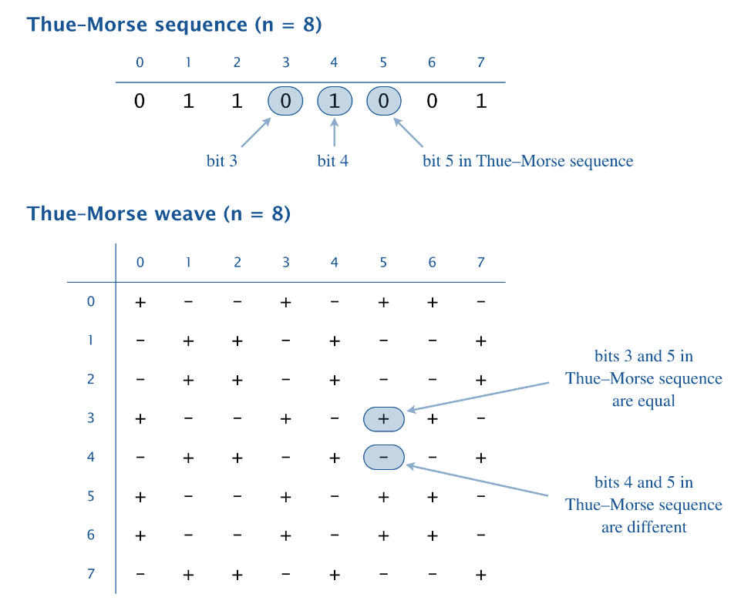

*Note*: you may assume that *n* is a positive integer (but it need not be a power of 2).

*The Thue–Morse sequence has many fascinating properties and arises in graphic design and in music composition.*

3. **Birthday problem.** Suppose that people enter a room one at a time. How people must enter until two share a birthday? Counterintuitively, after 23 people enter the room, there is approximately a 50–50 chance that two share a birthday. This phenomenon is known as the *birthday problem* or *birthday paradox*.

Write a program Birthday.java that takes two integer command-line arguments *n* and *trials* and performs the following experiment, *trials* times:

* + Choose a birthday for the next person, uniformly at random between 0 and n−1.
  + Have that person enter the room.
  + If that person shares a birthday with someone else in the room, stop; otherwise repeat.

In each experiment, count the number of people that enter the room. Print a table that summarizes the results (the count *i*, the number of times that exactly *i* people enter the room, and the fraction of times that *i* or fewer people enter the room) for each possible value of *i* from 1 until the fraction reaches (or exceeds) 50%.

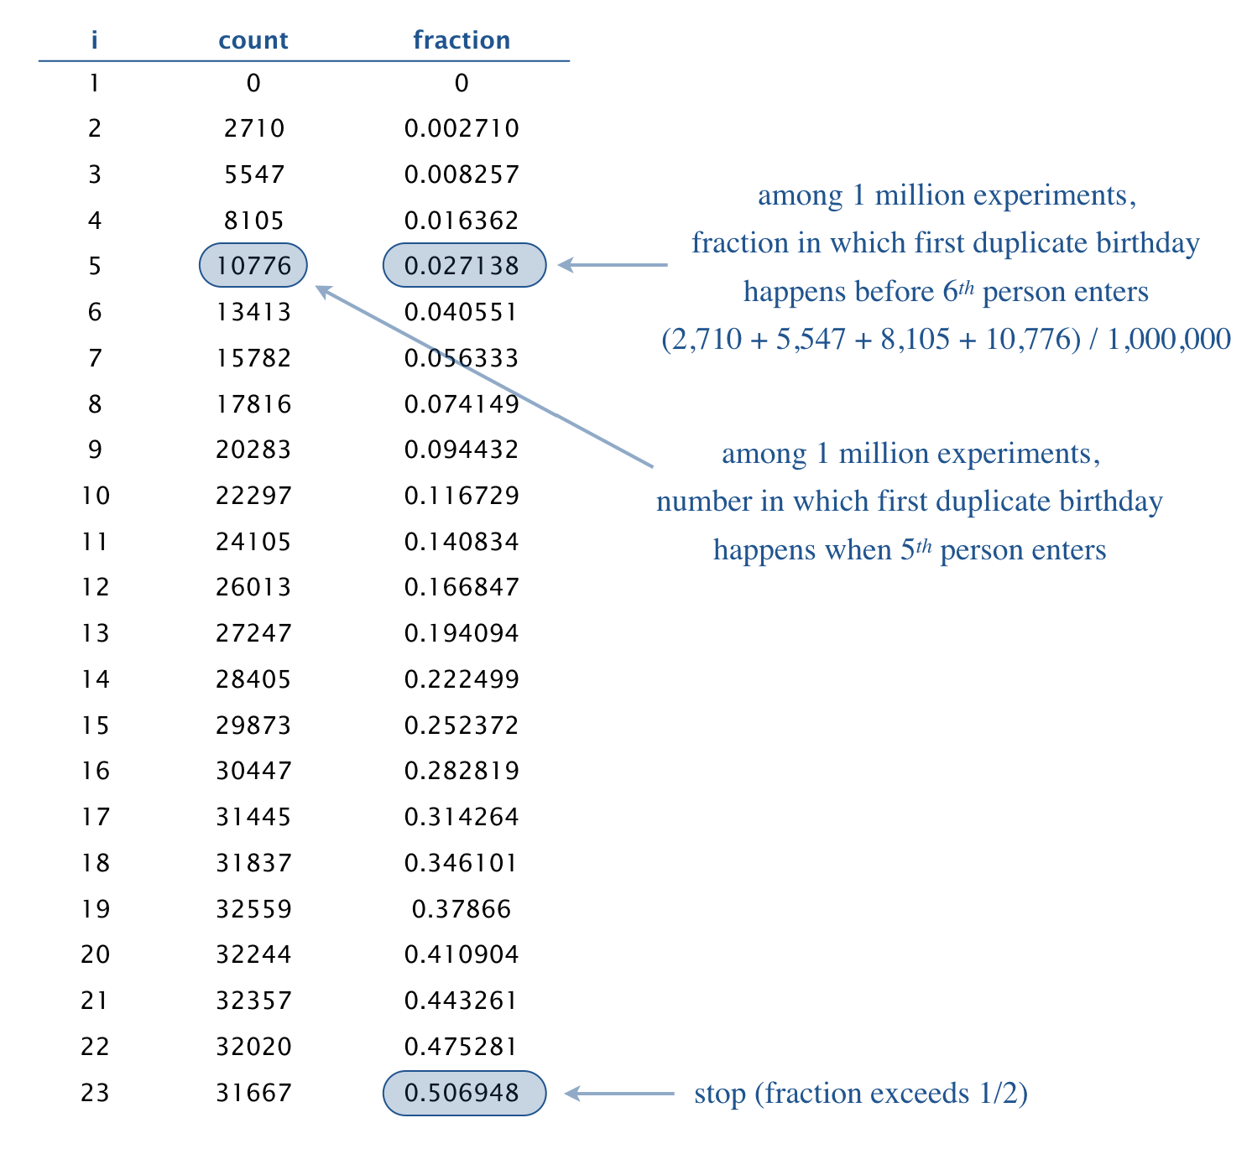~/Desktop/arrays> java Birthday 365 1000000

1 0 0.0

2 2710 0.00271

3 5547 0.008257

4 8105 0.016362

5 10776 0.027138

6 13413 0.040551

7 15782 0.056333

8 17816 0.074149

9 20283 0.094432

10 22297 0.116729

11 24105 0.140834

12 26013 0.166847

13 27247 0.194094

14 28405 0.222499

15 29873 0.252372

16 30447 0.282819

17 31445 0.314264

18 31837 0.346101

19 32559 0.37866

20 32244 0.410904

21 32357 0.443261

22 32020 0.475281

23 31667 0.506948

~/Desktop/arrays> java Birthday 31 1000000

1 0 0.0

2 32270 0.03227

3 62580 0.09485

4 87582 0.182432

5 105596 0.288028

6 114427 0.402455

7 115494 0.517949

*The birthday problem arises in many computer science applications, including hashing, cryptographic attacks, and testing random number generators.*

1. **Minesweeper.** *Minesweeper* is a 1960s era video game played on an *m*-by-*n* grid of cells. The goal is to deduce which cells contain hidden mines using clues about the number of mines in neighboring cells. Write a program Minesweeper.java that takes three integer command-line arguments *m*, *n*, and *k* and prints an *m*-by-*n* grid of cells with *k* mines, using asterisks for mines and integers for the neighboring mine counts (with two space characters between each cell). To do so,
   * Generate an *m*-by-*n* grid of cells, with exactly *k* of the *mn* cells containing mines, uniformly at random.
   * For each cell not containing a mine, count the number of neighboring mines (above, below, left, right, or diagonal).
2. ~/Desktop/arrays> java Minesweeper 9 9 10
3. 0 1 * 1 0 0 0 1 *
4. 1 3 2 2 0 0 0 1 1
5. * 2 * 1 0 0 1 1 1
6. 1 2 2 2 1 0 1 * 1
7. 0 1 2 * 1 0 1 1 1
8. 1 2 * 3 3 1 1 0 0
9. 1 * 3 * 2 * 1 0 0
10. 1 1 2 1 2 1 1 0 0
11. 0 0 0 0 0 0 0 0 0

**Submission.** Submit a .zip file containing DiscreteDistribution.java, ThueMorse.java, Birthday.java, and Minesweeper.java. You may not call library functions except those in the java.lang (such as Integer.parseInt() and Math.sqrt()). Use only Java features that have already been introduced in the course (e.g., loops and arrays, but not functions).